**CS 5570 Architecture Of Database Management Systems**

**\*\*\*\*\*\*\*\*\*\*\*\*\*\*\*\*\*\*\*\*\*\*\*\*\*\*\*\*\*\*\***

**Scheduler Project**

**Design Document**

**\*\*\*\*\*\*\*\*\*\*\*\*\*\*\*\*\*\*\*\*\*\*\*\*\*\*\*\*\*\*\***

**Team #4**

***Jonathan Wolfe***

***Rod Skoglund***

***Ergin Bostanci***

***Pavan Yannamaneni***

Table of Contents

**Top Level Design** 3

**Transaction Generator** 4

**Transaction Manager** 5

**Scheduler** 6

**Process Read or Write Operation** 7

**Process RW Operation – Handle Conflicts** 8

**Process Commit Operation** 9

**Process Abort Operation** 10

# **Top Level Design**

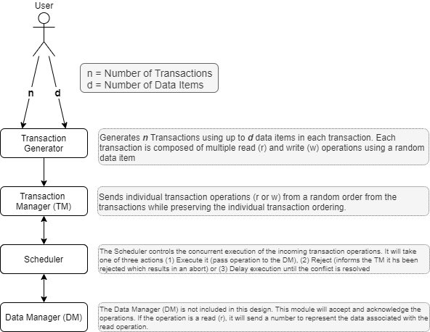

# **Transaction Generator**

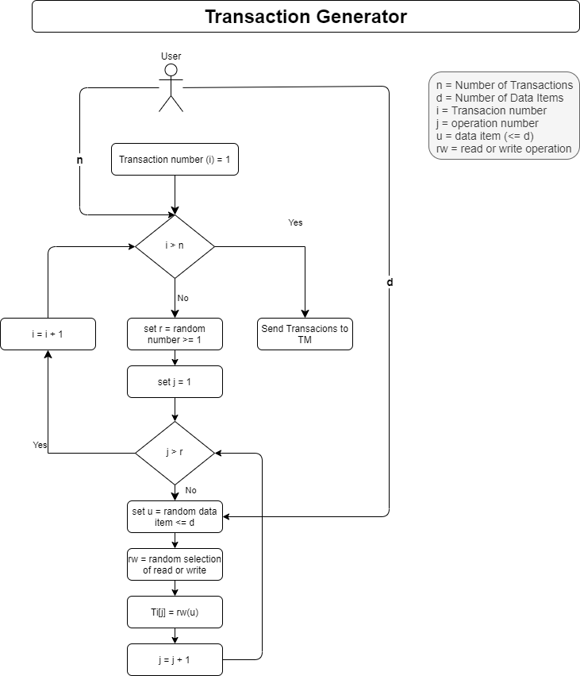

# **Transaction Manager**

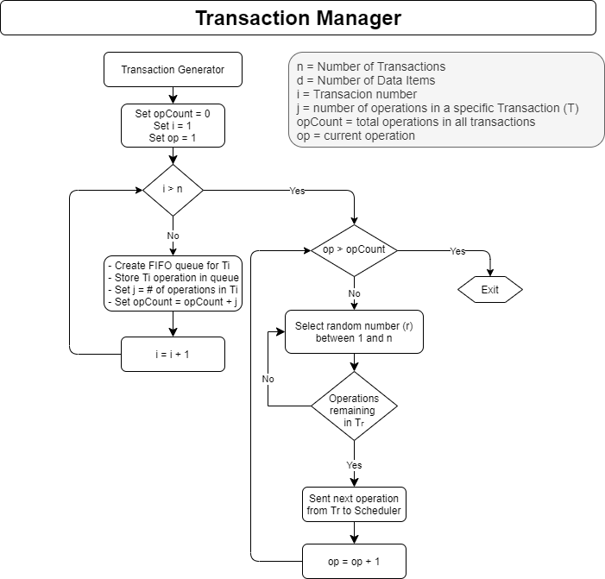

# **Scheduler**

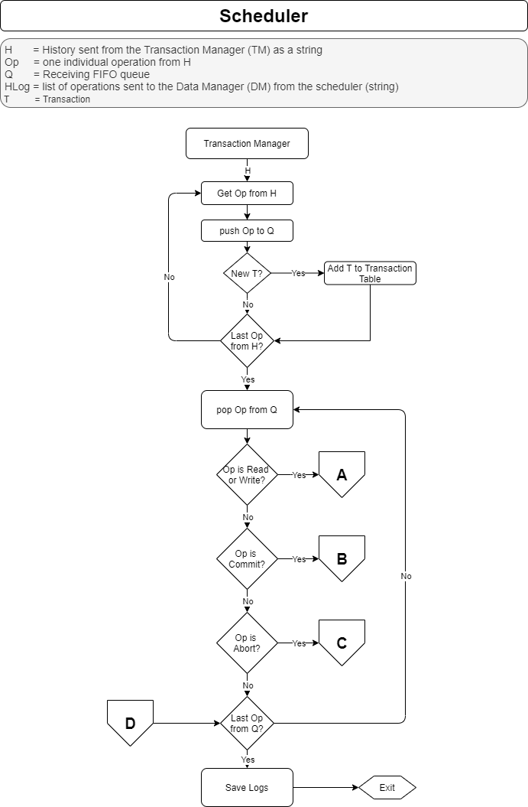

# **Process Read or Write Operation**

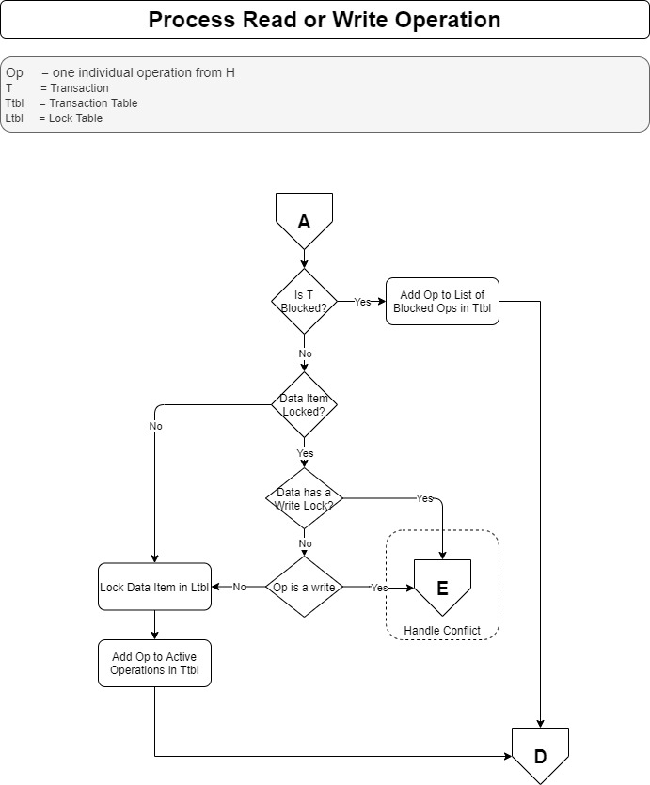

# **Process RW Operation – Handle Conflicts**

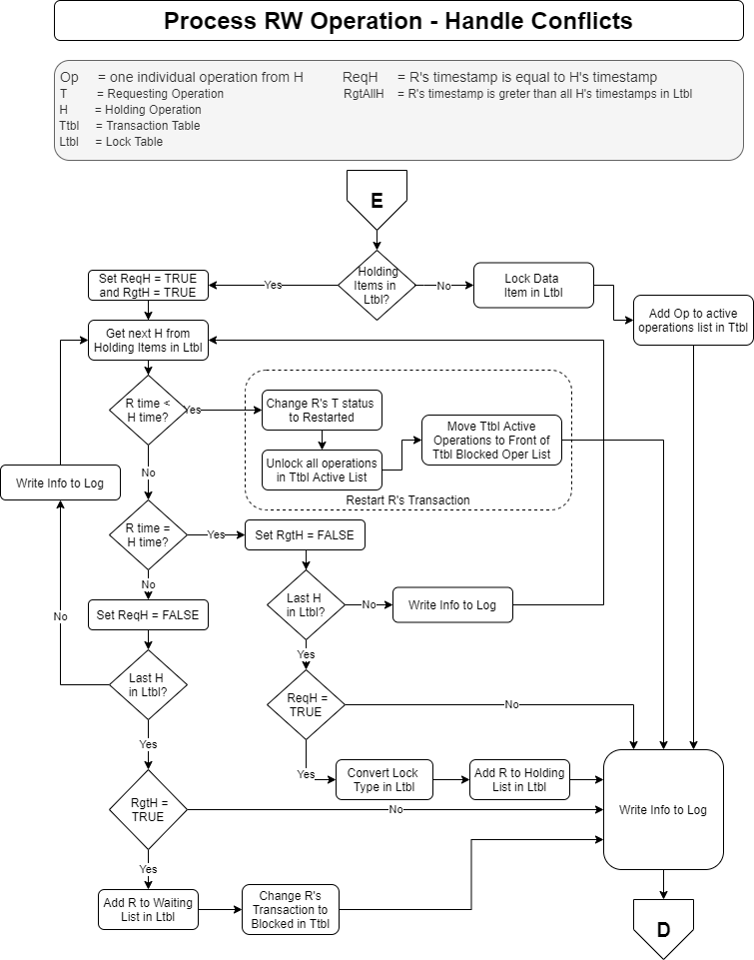

# **Process Commit Operation**

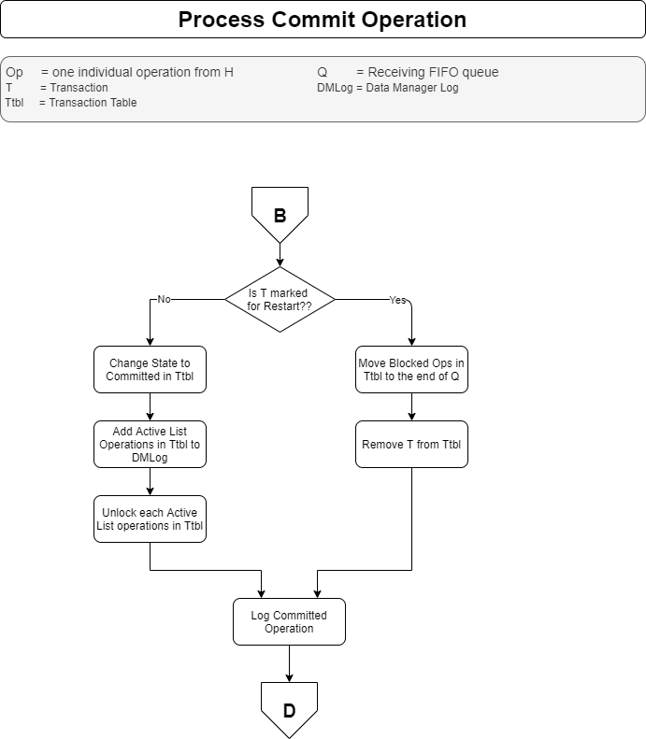

# **Process Abort Operation**

